[](http://www.skywind.me/blog/wp-content/uploads/2011/04/PPT11.png)

2009年在上海 CGDC的演讲稿《游戏地图自动生成》，该算法主要用来生成山地峡谷地图。

[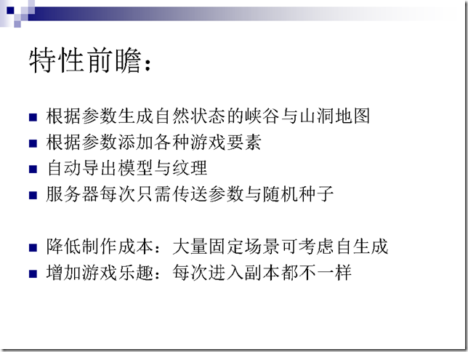](http://www.skywind.me/blog/wp-content/uploads/2011/04/PPT2.png)  
[](http://www.skywind.me/blog/wp-content/uploads/2011/04/PPT3.png)  
[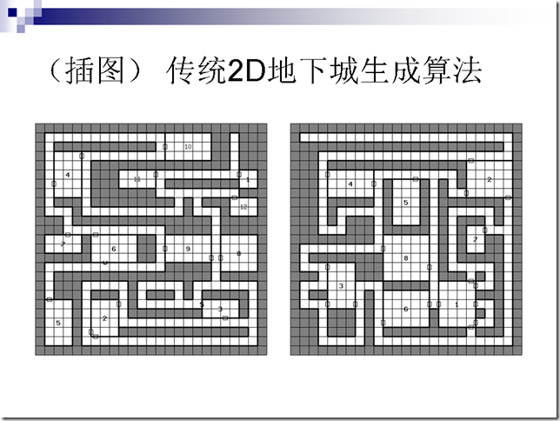](http://www.skywind.me/blog/wp-content/uploads/2011/04/PPT4.png)  
[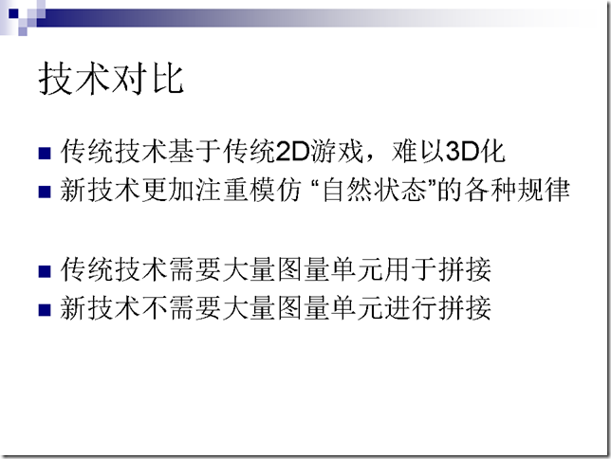](http://www.skywind.me/blog/wp-content/uploads/2011/04/PPT5.png)  
[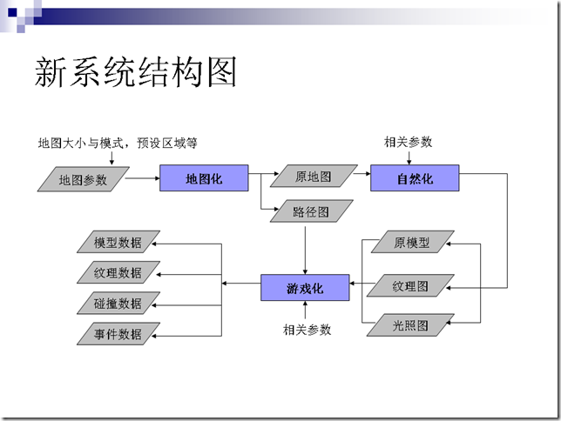](http://www.skywind.me/blog/wp-content/uploads/2011/04/PPT6.png)  
[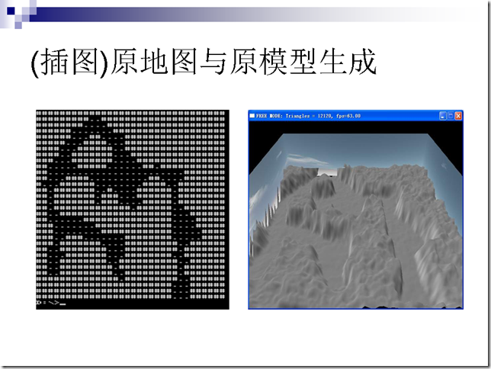](http://www.skywind.me/blog/wp-content/uploads/2011/04/PPT7.png)  
[](http://www.skywind.me/blog/wp-content/uploads/2011/04/PPT8.png)  
[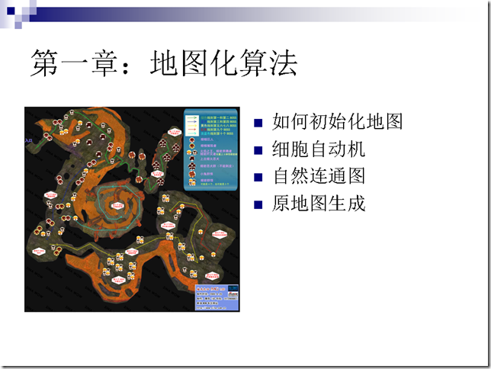](http://www.skywind.me/blog/wp-content/uploads/2011/04/PPT9.png)  
[](http://www.skywind.me/blog/wp-content/uploads/2011/04/PPT10.png)  
[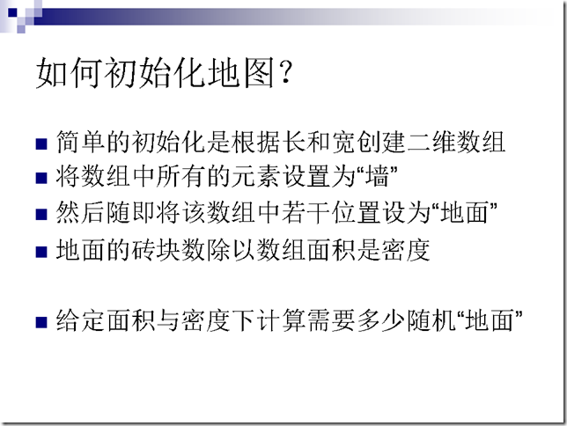](http://www.skywind.me/blog/wp-content/uploads/2011/04/PPT111.png)  
[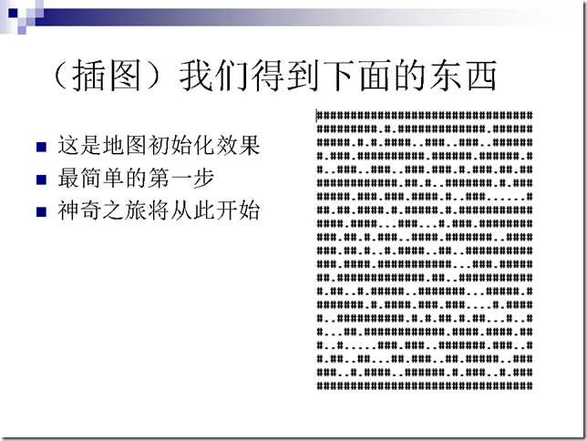](http://www.skywind.me/blog/wp-content/uploads/2011/04/PPT12.png)  
[](http://www.skywind.me/blog/wp-content/uploads/2011/04/PPT13.png)  
[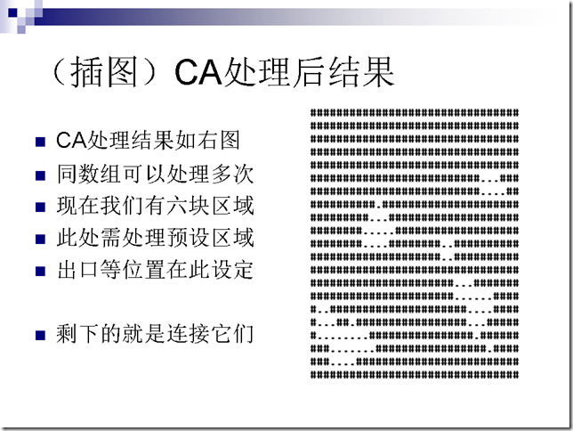](http://www.skywind.me/blog/wp-content/uploads/2011/04/PPT14.png)  
[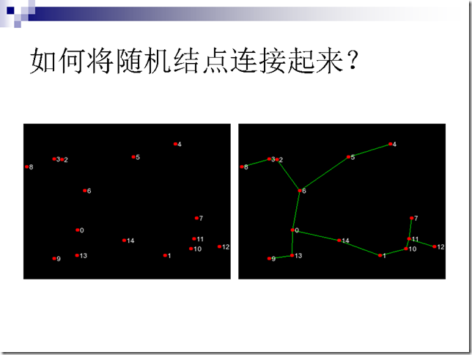](http://www.skywind.me/blog/wp-content/uploads/2011/04/PPT15.png)  
[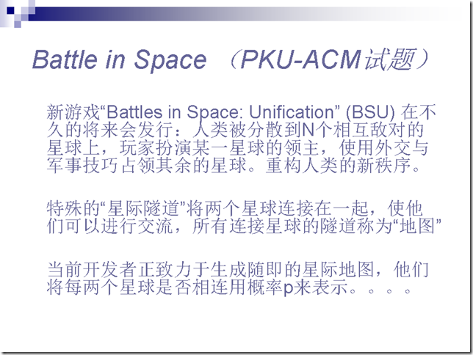](http://www.skywind.me/blog/wp-content/uploads/2011/04/PPT16.png)  
[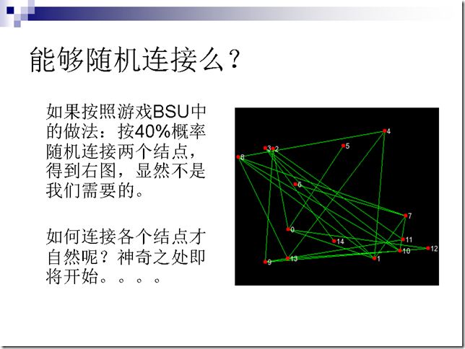](http://www.skywind.me/blog/wp-content/uploads/2011/04/PPT17.png)  
[](http://www.skywind.me/blog/wp-content/uploads/2011/04/PPT18.png)  
[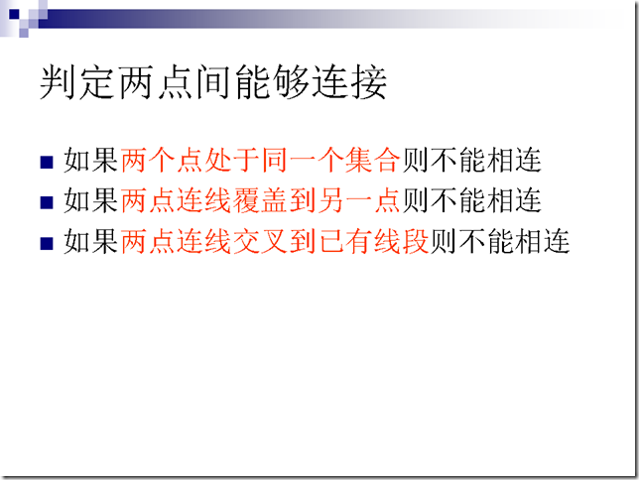](http://www.skywind.me/blog/wp-content/uploads/2011/04/PPT19.png)  
[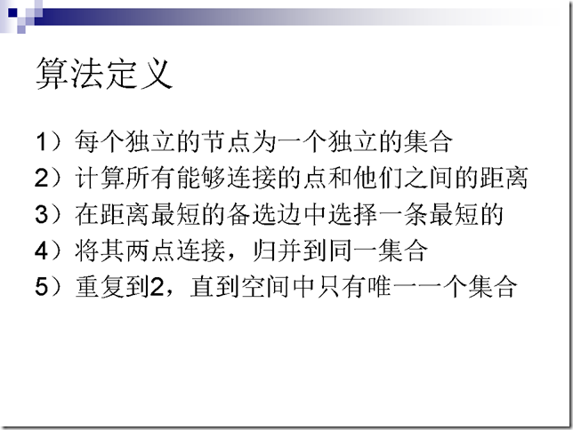](http://www.skywind.me/blog/wp-content/uploads/2011/04/PPT20.png)  
[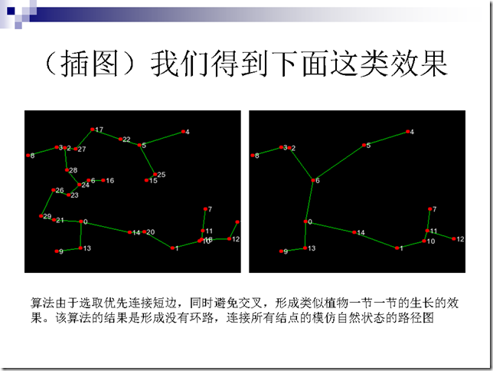](http://www.skywind.me/blog/wp-content/uploads/2011/04/PPT21.png)  
[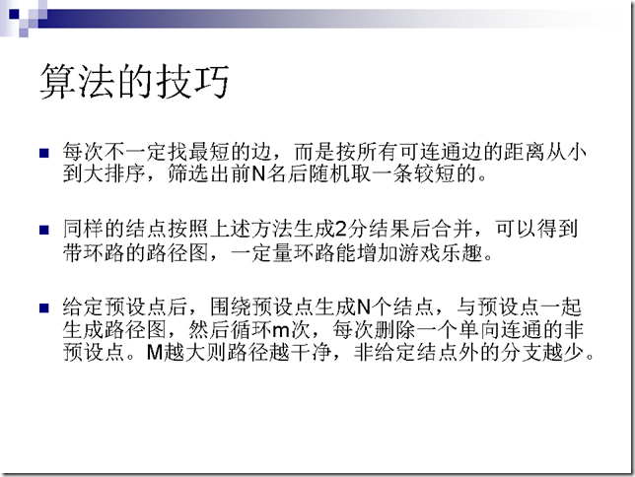](http://www.skywind.me/blog/wp-content/uploads/2011/04/PPT22.png)  
[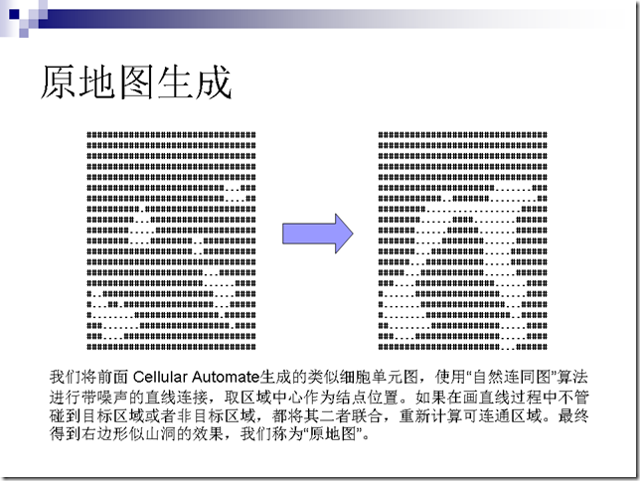](http://www.skywind.me/blog/wp-content/uploads/2011/04/PPT23.png)  
[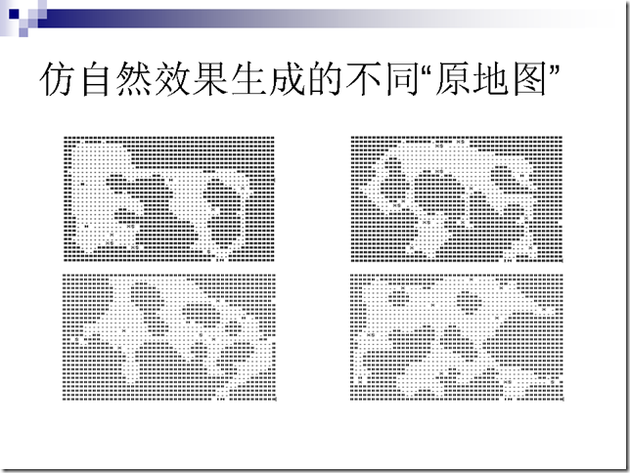](http://www.skywind.me/blog/wp-content/uploads/2011/04/PPT24.png)  
[](http://www.skywind.me/blog/wp-content/uploads/2011/04/PPT25.png)  
[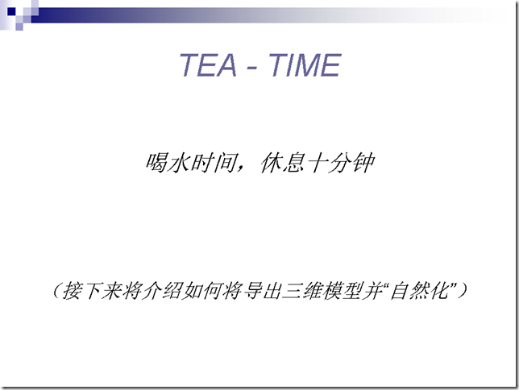](http://www.skywind.me/blog/wp-content/uploads/2011/04/PPT26.png)  
[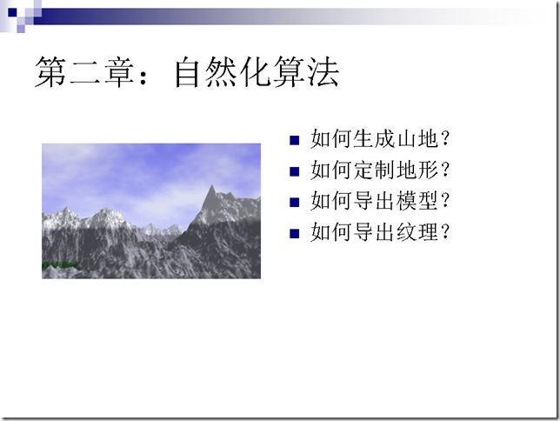](http://www.skywind.me/blog/wp-content/uploads/2011/04/PPT27.png)  
[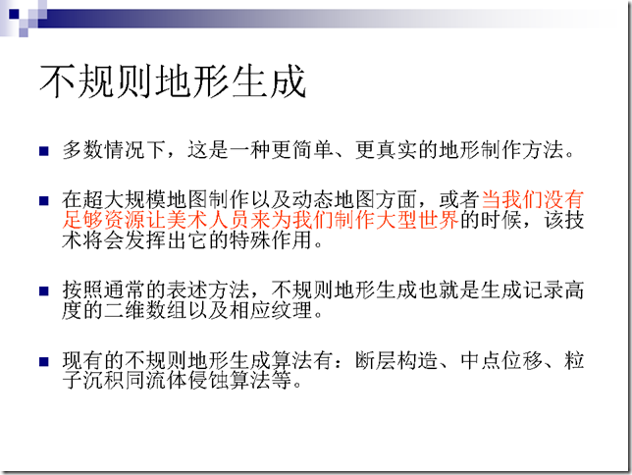](http://www.skywind.me/blog/wp-content/uploads/2011/04/PPT28.png)  
[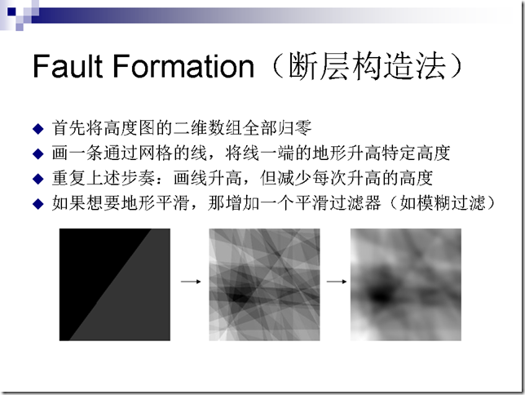](http://www.skywind.me/blog/wp-content/uploads/2011/04/PPT29.png)  
[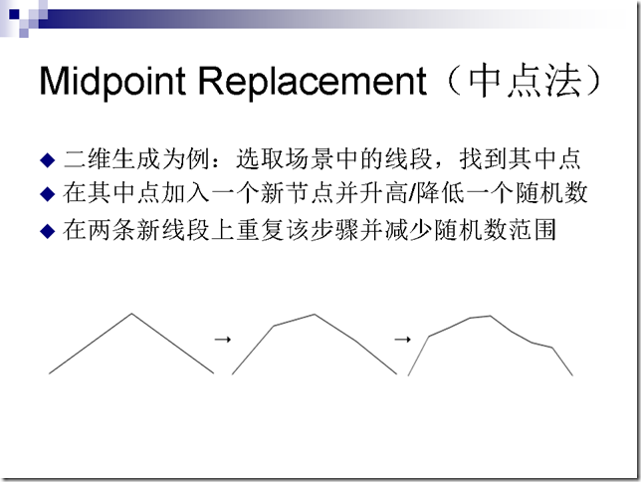](http://www.skywind.me/blog/wp-content/uploads/2011/04/PPT30.png)  
[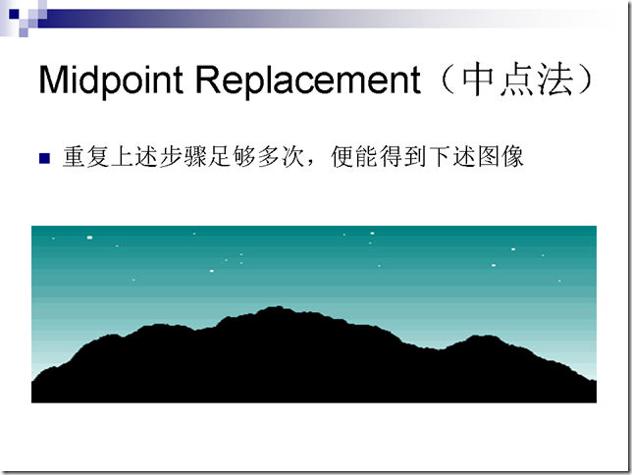](http://www.skywind.me/blog/wp-content/uploads/2011/04/PPT31.png)  
[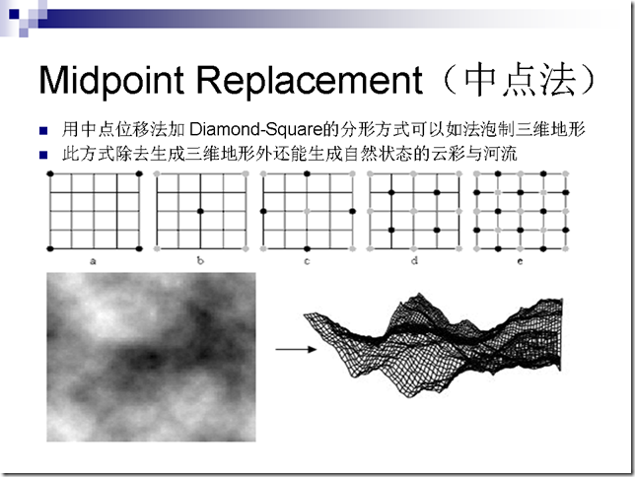](http://www.skywind.me/blog/wp-content/uploads/2011/04/PPT32.png)  
[](http://www.skywind.me/blog/wp-content/uploads/2011/04/PPT33.png)  
[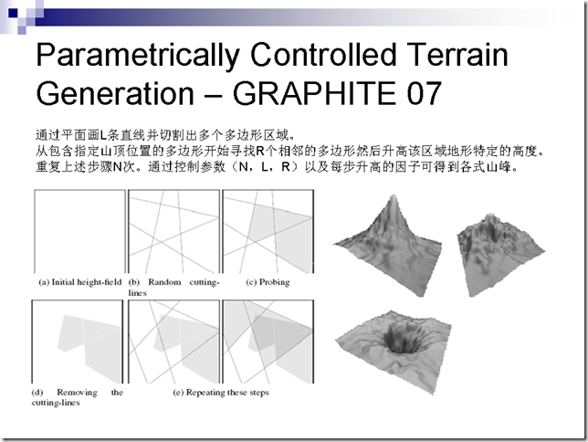](http://www.skywind.me/blog/wp-content/uploads/2011/04/PPT34.png)  
[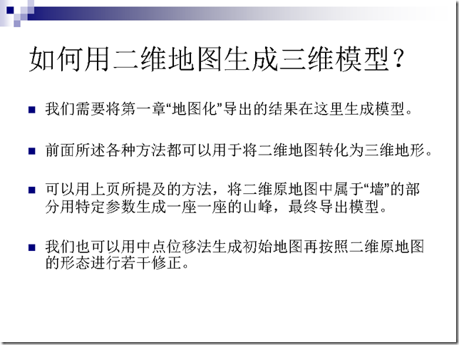](http://www.skywind.me/blog/wp-content/uploads/2011/04/PPT35.png)  
[](http://www.skywind.me/blog/wp-content/uploads/2011/04/PPT36.png)  
[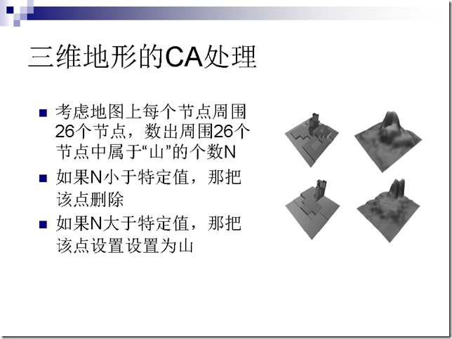](http://www.skywind.me/blog/wp-content/uploads/2011/04/PPT37.png)  
[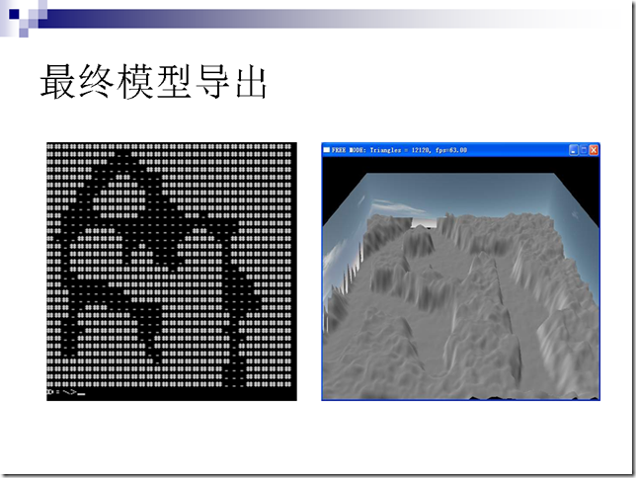](http://www.skywind.me/blog/wp-content/uploads/2011/04/PPT38.png)  
[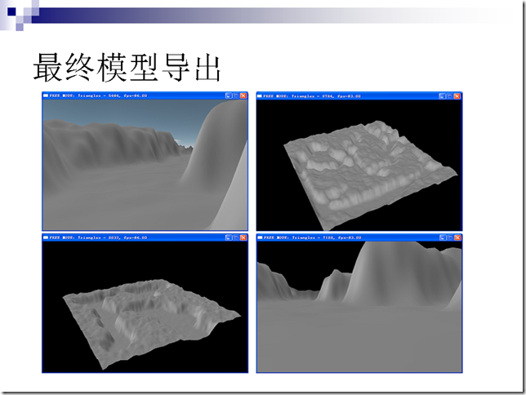](http://www.skywind.me/blog/wp-content/uploads/2011/04/PPT39.png)  
[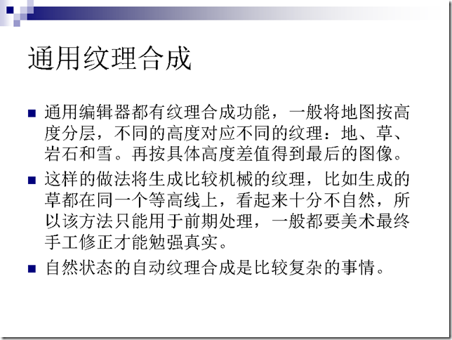](http://www.skywind.me/blog/wp-content/uploads/2011/04/PPT40.png)  
[](http://www.skywind.me/blog/wp-content/uploads/2011/04/PPT41.png)  
[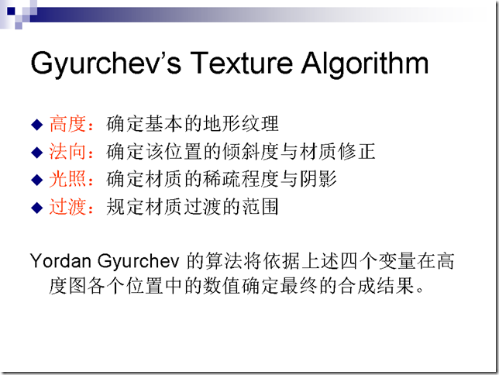](http://www.skywind.me/blog/wp-content/uploads/2011/04/PPT42.png)  
[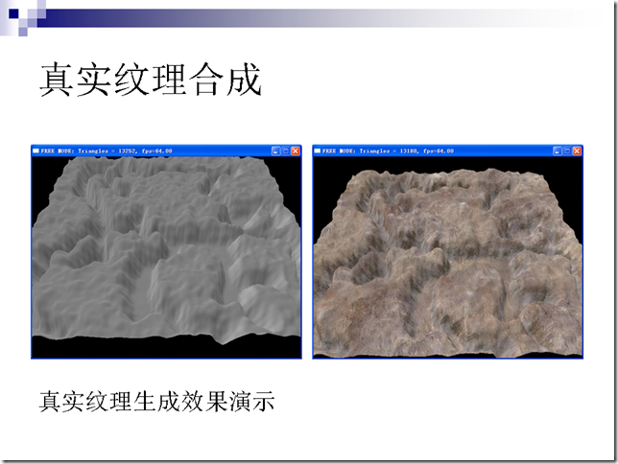](http://www.skywind.me/blog/wp-content/uploads/2011/04/PPT43.png)  
[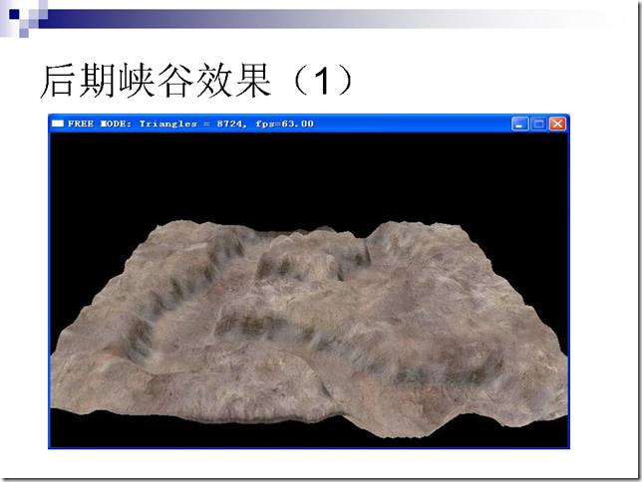](http://www.skywind.me/blog/wp-content/uploads/2011/04/PPT44.png)  
[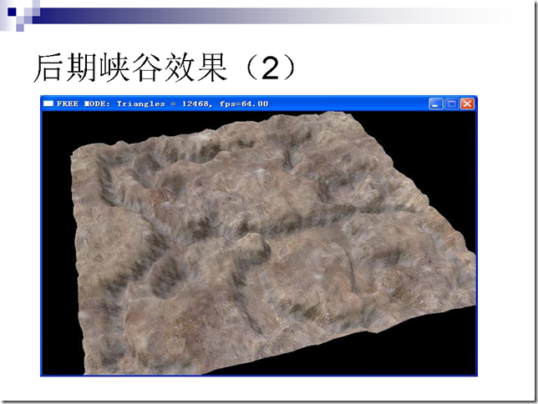](http://www.skywind.me/blog/wp-content/uploads/2011/04/PPT45.png)  
[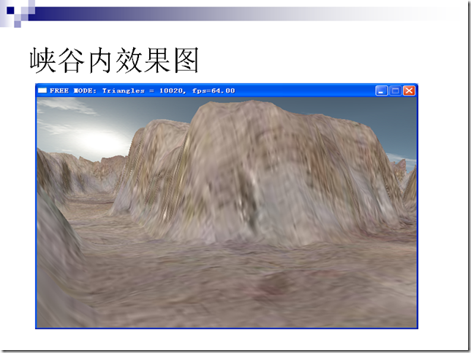](http://www.skywind.me/blog/wp-content/uploads/2011/04/PPT46.png)  
[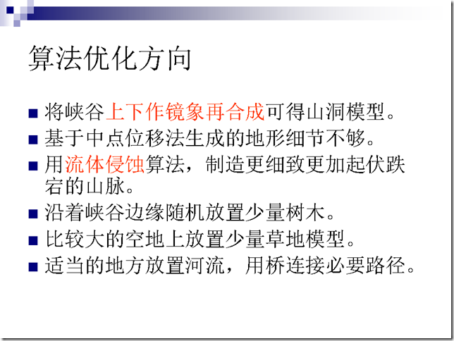](http://www.skywind.me/blog/wp-content/uploads/2011/04/PPT47.png)  
[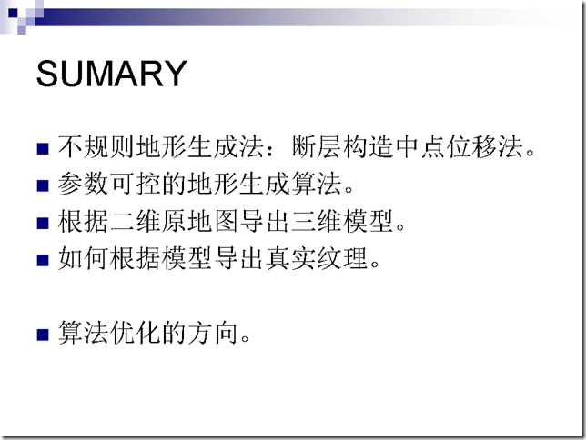](http://www.skywind.me/blog/wp-content/uploads/2011/04/PPT48.png)  
[](http://www.skywind.me/blog/wp-content/uploads/2011/04/PPT49.png)  
[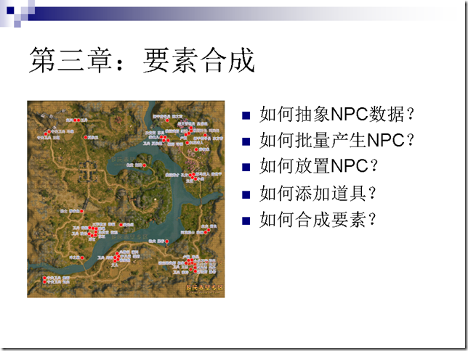](http://www.skywind.me/blog/wp-content/uploads/2011/04/PPT50.png)  
[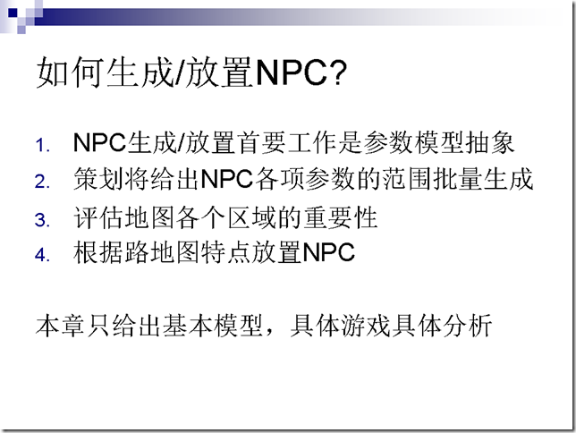](http://www.skywind.me/blog/wp-content/uploads/2011/04/PPT51.png)  
[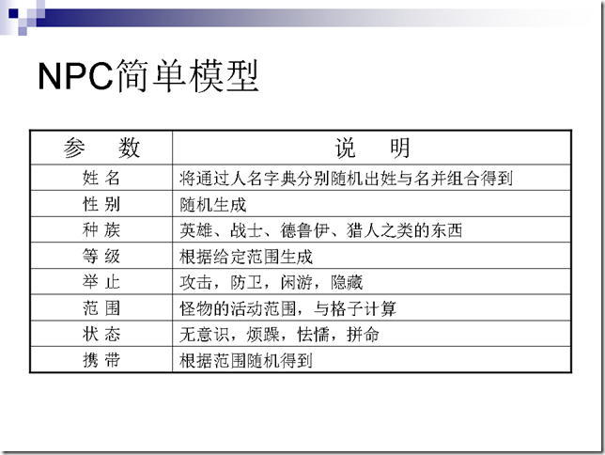](http://www.skywind.me/blog/wp-content/uploads/2011/04/PPT52.png)  
[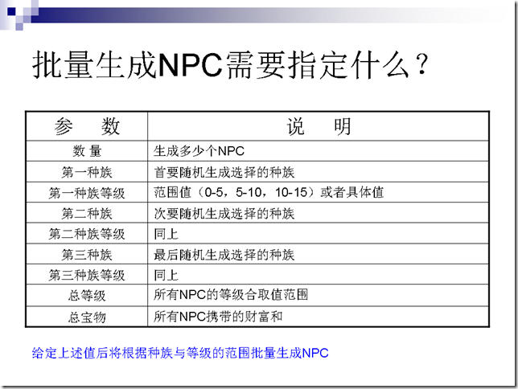](http://www.skywind.me/blog/wp-content/uploads/2011/04/PPT53.png)  
[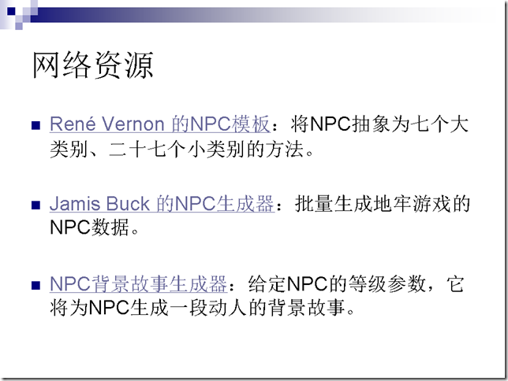](http://www.skywind.me/blog/wp-content/uploads/2011/04/PPT54.png)  
[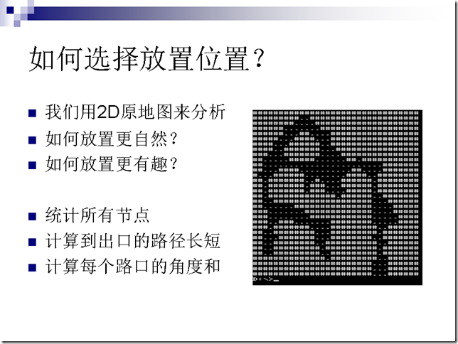](http://www.skywind.me/blog/wp-content/uploads/2011/04/PPT55.png)  
[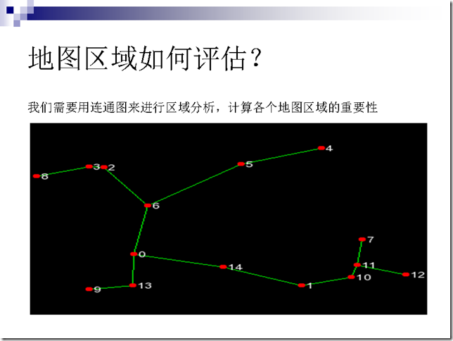](http://www.skywind.me/blog/wp-content/uploads/2011/04/PPT56.png)  
[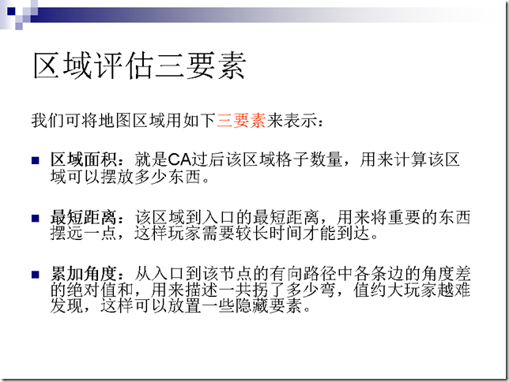](http://www.skywind.me/blog/wp-content/uploads/2011/04/PPT57.png)  
[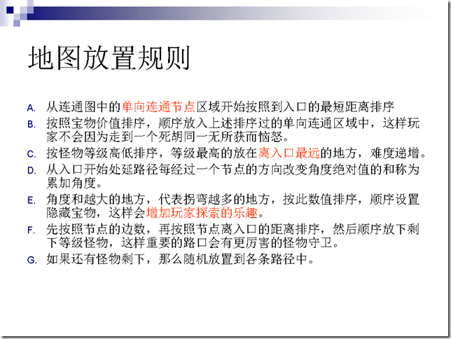](http://www.skywind.me/blog/wp-content/uploads/2011/04/PPT58.png)  
[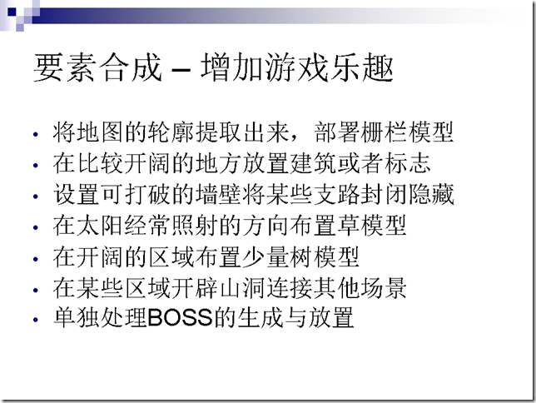](http://www.skywind.me/blog/wp-content/uploads/2011/04/PPT59.png)  
[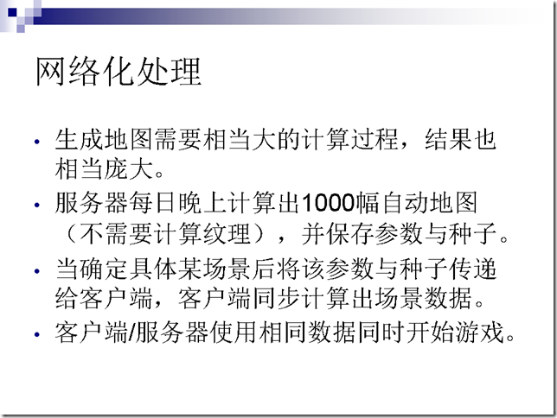](http://www.skywind.me/blog/wp-content/uploads/2011/04/PPT60.png)  
[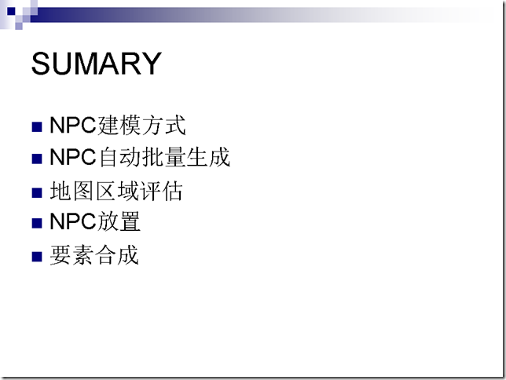](http://www.skywind.me/blog/wp-content/uploads/2011/04/PPT61.png)  
[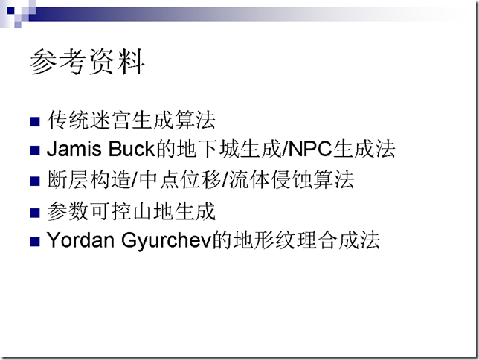](http://www.skywind.me/blog/wp-content/uploads/2011/04/PPT62.png)  
[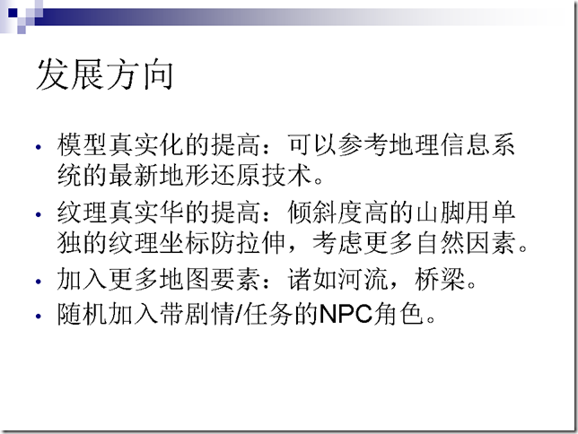](http://www.skywind.me/blog/wp-content/uploads/2011/04/PPT63.png)  
[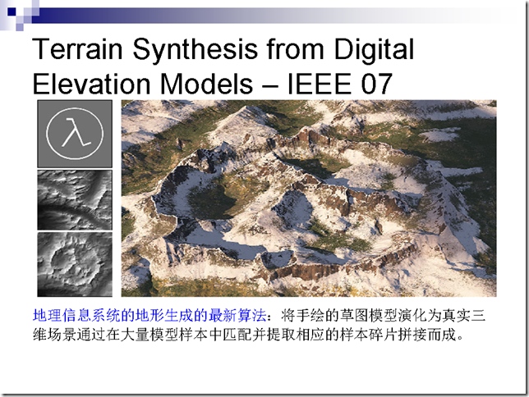](http://www.skywind.me/blog/wp-content/uploads/2011/04/PPT64.png)  
[](http://www.skywind.me/blog/wp-content/uploads/2011/04/PPT65.png)